**Project Outputs**

Data frame = SURdf (There in the CODE file)

Head(first 6 rows and cols data)

Dimensions of data (No of ROWS,COLS in Data)

Structure of Data frame (shows COLUMN names and Data types)

Summary (For all COLUMNS, gives All statistical details like Mean,Mode,IQR(Inter Quartile Range),Median)

Displaying all COLUMN names

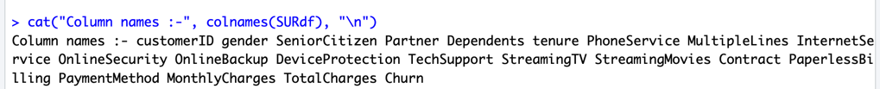

Data Type of each COLUMN

Rough / Indirect Check of Missing Values

Dropping the “customerID” column

* On deep analysis, we can find some indirect missingness in our data (which can be in form of blankspaces). Let's see that!

Checking missing values in each column

* Here we see that the TotalCharges has 11 missing values. Let's check this data.

Filtering rows where ‘TotalCharges’ is NA and Viewing rows with missing ‘TotalCharges’

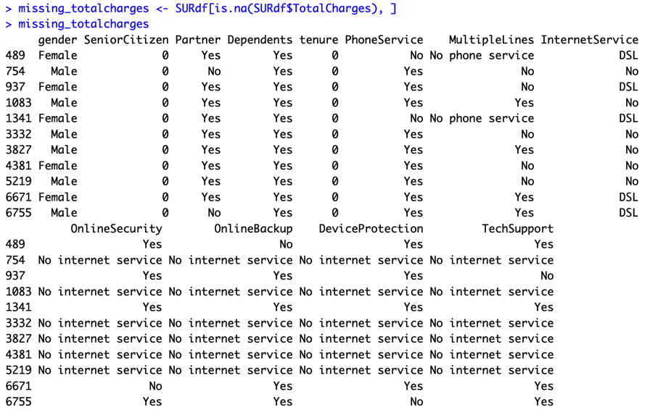

* It can also be noted that the Tenure column is 0 for these entries even though the MonthlyCharges column is not empty. Let's see if there are any other 0 values in the tenure column.

Get the indices of rows where 'tenure' is equal to 0

* There are no additional missing values in the Tenure column. Let's delete the rows with missing values in Tenure columns since there are only 11 rows and deleting them will not affect the data.

Drop rows where 'tenure' is equal to 0

To solve the problem of missing values in TotalCharges column, I decided to fill it with the mean of TotalCharges values.

Count the number of missing values (NA) in each column

Map values in the 'SeniorCitizen' column: 0 -> "No", 1 -> "Yes"

Summarize the 'InternetService' column

Summarize the specified numerical columns

Data Visualization

PLOT – 1 A and B

* 26.6 % of customers switched to another firm.
* Customers are 49.5 % female and 50.5 % male.

Gender count where Churn is NO

Gender count where churn is YES

* There is negligible difference in customer percentage/ count who chnaged the service provider. Both genders behaved in similar fashion when it comes to migrating to another service provider/firm.

* About 75% of customer with Month-to-Month Contract opted to move out as compared to 13% of customers with One Year Contract and 3% with Two Year Contract.

* Major customers who moved out were having Electronic Check as Payment Method.
* Customers who opted for Credit-Card automatic transfer or Bank Automatic Transfer and Mailed Check as Payment Method were less likely to move out.

Get unique values from the 'InternetService' column

Filter rows where gender is "Male" and count combinations of InternetService and Churn

Filter rows where gender is "Male" and count combinations of InternetService and Churn

* A lot of customers choose the Fiber optic service and it's also evident that the customers who use Fiber optic have high churn rate, this might suggest a dissatisfaction with this type of internet service.
* Customers having DSL service are majority in number and have less churn rate compared to Fibre optic service.

* Customers without dependents are more likely to churn

* Customers that doesn't have partners are more likely to churn

* Most customers churn in the absence of online security,

* Customers with Paperless Billing are most likely to churn.

* Customers with no TechSupport are most likely to migrate to another service provider.

* Very small fraction of customers don't have a phone service and out of that, 1/3rd Customers are more likely to churn.

* Customers with higher Monthly Charges are also more likely to churn

• **High Total Charges customers are less likely to churn**, likely due to longer tenure or satisfaction with services.

• **Churn is more frequent among customers with lower Total Charges,** highlighting a potential area to focus on improving customer retention strategies for new or low-value customers.

* New customers are more likely to churn

Strong correlations between tenure, MonthlyCharges, and TotalCharges suggest that longer-tenure customers contribute significantly to revenue.

Lower tenure and shorter Contract types are the strongest predictors of churn, emphasizing the need to focus on retaining short-term and new customers.

Encouraging longer contracts and addressing dissatisfaction among customers with short tenure or month-to-month plans can help reduce churn.

Since the numerical features are distributed over different value ranges, I will use standard scalar to scale them down to the same range.

**Machine Learning Model Evaluations and Predictions**

KNN Algorithm

SVM Algorithm

RANDOM FOREST Algorithm

Random forest Confusion Matrix

Random Forest ROC Curve

Logistic Regression Algorithm

The dataset is **imbalanced**, with approximately 74% of the samples belonging to class 0 and only 26% to class 1.

Logistic Regression CLASSIFICATION REPORT

Logistic Regression CONFUSION MATRIX

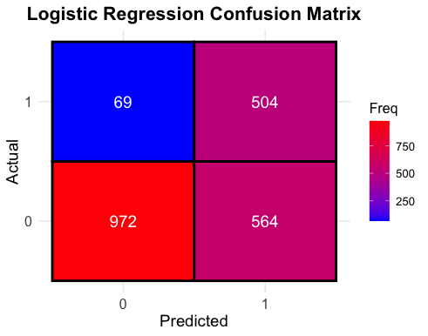

Logistic Regression – ROC Curve

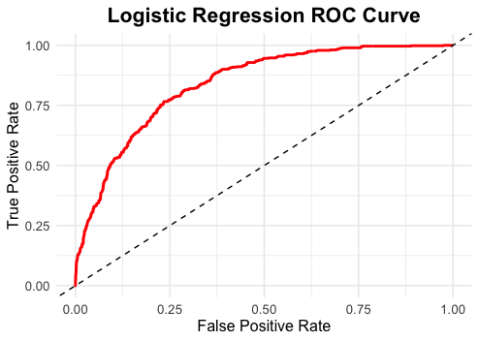

DECISION TREE

Decision Tree - CLASSIFICATION REPORT

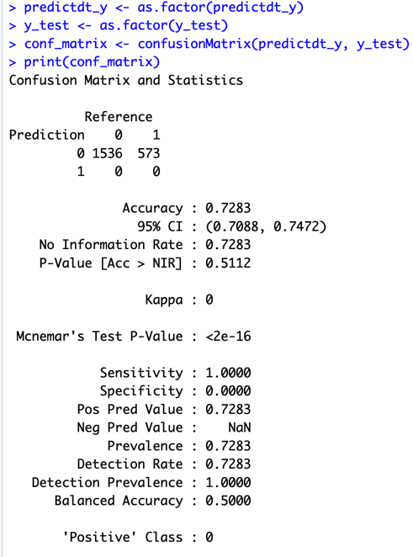

XG BOOST CLASSIFIER

XGBOOST Classification Report

XGBOOST Confusion Matrix

